
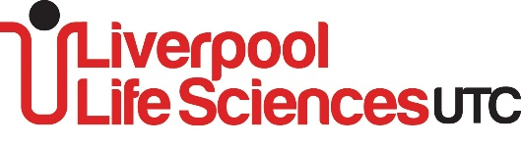
lifesciencesutc.co.uk thestudioliverpool.uk

All students will take part in Project Based Learning and Coaching activities as part of their core timetable.

Medicine Direct Entry Requirements:  At least a score of 13 points from the eight GCSE subjects where 7-9 = 2 points; 6 = 1 point. A minimum of a grade 6 in the following required subjects:  Biology, Chemistry, and Physics (or Core & Additional Science)  English Language and Mathematics | Entry Requirements:  Average point score should be above 5  All A-level courses require passes at GCSE English and mathematics, the required subject-specific grade and good passes in at least two other subjects.  A-Level Biology: minimum 6 in GCSE Biology or a Combined Science qualification  A-Level Chemistry: minimum 6 in GCSE Chemistry or a Combined Science qualification and 6 in Mathematics  A-Level Physics: minimum 6 in GCSE Physics or a Combined Science qualification and 6 in Mathematics  A-Level Mathematics: minimum 6 in GCSE Mathematics 7 or above preferred  A-level Further Maths minimum 8 in GCSE Mathematics  A-Level Engineering: minimum 6 in GCSE Mathematics and 6 in GCSE Physics or a Combined Science qualification  A-Level Business: minimum 5 in English Language or Literature  A-Level Computer Science & AAQ courses: minimum 6 in GCSE Mathematics and GCSE Computer Science  A-Level Psychology, Sociology and Diploma in Criminology: minimum 6 in GCSE English Language or Literature  A-Level English Literature: minimum 6 in GCSE English Language and English Literature  A-Level History: minimum 6 in GCSE History and 5 in English Language  A-Level Geography: minimum 6 in GCSE Geography and 5 in English Language  Art, Graphics, Lens-based media: minimum 6 in GCSE in an Art & Design subject  A-Level Economics: minimum 6 in GCSE Mathematics  A-Level Philosophy and Ethics: minimum 6 in GCSE Religious Studies and/or 6 in GCSE English
BTEC | 5 x GCSE including core subjects and 2 others. These can be in GCSE or Level 2 Merits.  Applicants must have at least a 4 in GCSE English Language and at least a 4 in GCSE Mathematics.
T-Level | 5 x GCSE including core subjects and 2 others. These can be in GCSE or Level 2 Merits.  T-Level Digital Software Development.  T-Level Design and Development for Engineering and Manufacturing.  Applicants must have at least a 5 in GCSE English Language and at least a 5 in GCSE Mathematics.

